MISSION WITH A VISION CHARITY WALK:
The Next Step Towards Eradicating Female
Genital Mutilation and Child Marriage in Kenya
www.missionwithavision.com

October 31 – November 6, 2022

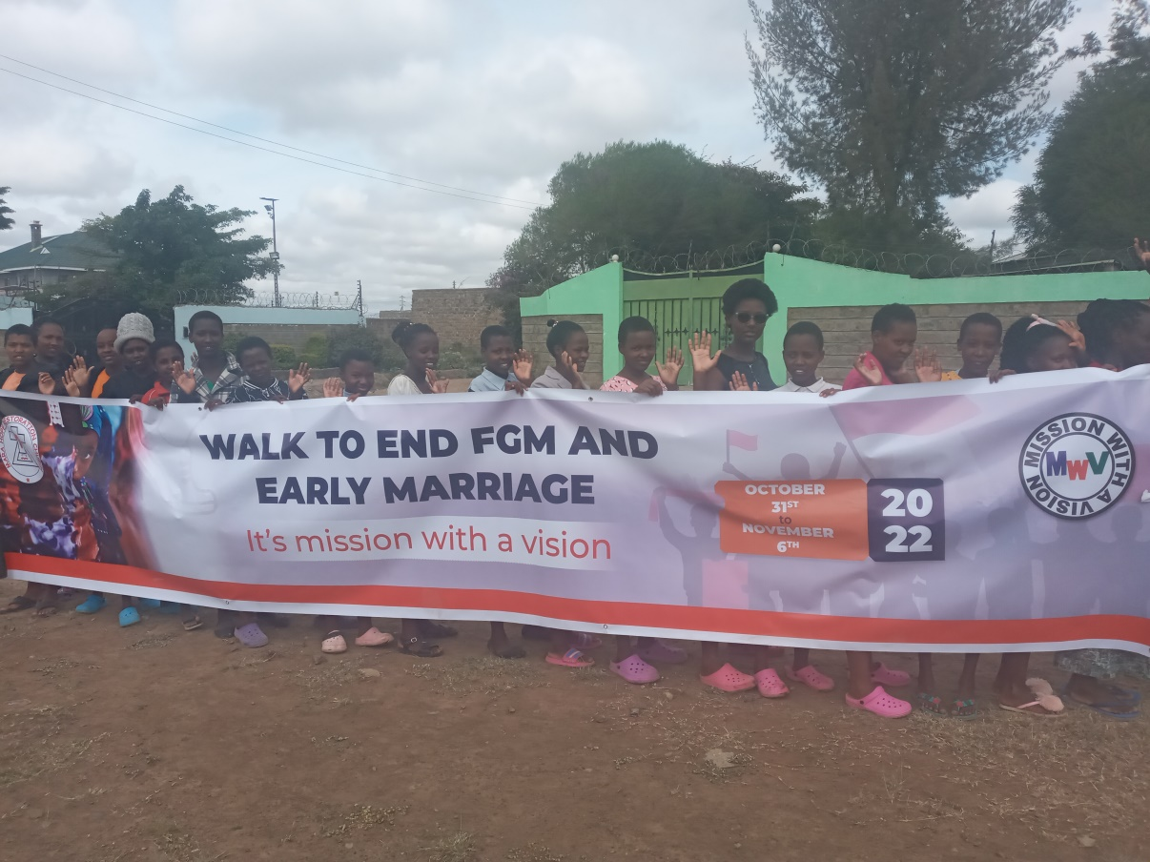

BACKGROUND
At the end of October, Patrick Ngigi Director Mission with a vision and his wife will march 168 km from of Narok through Kajiado county to the Kenyan capital of Nairobi. Their mission: to raise the flag in the fight to eliminate female genital mutilation (FGM) and child marriage and help set the stage for Kenya to become the first African nation to eliminate this horrific and illegal practice. The target is to raise funds towards supporting total elimination of this harmful practice.

ORGANIZER

The Mission With A Vision organization located in Narok is a leader in the fight to keep girls safe from FGM and prevent illegal childhood marriage. The Mission has an exceptional record of achievement protecting and educating girls and young women. Over the past two decades, they have come to the aid of more than 1,200 girls, kept them safe, nursed them back to health and made sure they received an education. In addition, the organization’s staff works to ensure that the girls are equipped to enter the job market so that they can lead fully independent lives and adequately support their families once they complete their studies.
WHO

The March will be led by Josephine Paissany, the Mission’s safehouse manager accompanied by her husband be the Bishop Patrick Ngigi. Both Paisanny and Ngigi were teachers who have spent the past 25 years helping girls fleeing FGM. They will be joined by many of the girls currently residing at the Mission’s safehouse and by a number of Maasai elders, two members of parliament and representatives from a variety of civil society organizations, both Kenyan and from overseas in the first 10kmand the last 10km. Only Josephine and Patrick have volunteered to walk the entire 168 kilometers.

SPONSOR THE WALK

Members of the public and the business community can show their support for the march by pledging to contribute a sum of money for each kilometer covered by a participant. For example, if you pledge one dollar per kilometer for a participant who marches all 168 km between Narok and Nairobi the Mission will receive $336

FACTS AND FIGURES

- How long is the march expected to last: 7 days
- What is the distance from Narok through Ngong to Nairobi: 168 km
- How many kilometers will the marchers complete per day: ~25-30 per day
- How many people will march: the number of participants will vary from day to day but at least two individuals are expected to complete the entire route
- We target to raise about $100,000 which will go into paying school fees for more rescued girls, promoting advocacy against FGM, Building and equipping of a vocational training center for rescued girls and other activities that will help eradicate FGM and forced early marriage.

WHAT IS MISSION WITH A VISION?

Over the past decade the Mission with a Vision organization (MWV), the organizer of the March, has rescued, kept safe and educated more than 1,200 girls fleeing FGM and childhood marriage. During that time, frightened adolescent girls with little or no education have grown to become independent women who, by example, are helping to break the cultural norms that support genital cutting and childhood marriage.
The Mission’s work takes place in Narok and kajiado county which are FGM hotspots and home to the Maasai, which is one of the communities that continues to practice FGM despite a government ban on the practice. Working with local leaders, the Kenyan Childrens Department and local police, the Mission’s work has had a significant impact both on the girls who have been rescued and, increasingly, on local attitudes toward these practices.
The work begins with the rescue of the girls, many of whom have fled their villages and are brought in by the police or simply wander in on their own having heard that the Mission provides a safe haven and will sponsor their education. While the majority go on to secondary school and then university , a rare occurrence for a Maasai girl, many have received scholarships for college and university and have forged successful professional careers.
FOR ADDITIONAL INFORMATION:

Kenya: Mission With A Vision, c/o Josephine Passiany , vision.mission@yahoo.com, 254 724 799 247

United Kingdom: Our Charity walk champions in the UK
Charlotte Brooks
Rachel Horner and Mission Direct
Dan colins
Gill Martin
Gill Neale
Graham Night
Lucy Noon
Benj Goud

USA: African Childrens Haven, 4012 Pirates Beach, Galveston, TX 77554, africanchildrenshaven@comcast.net

Sponsors so far
-African Children’s Haven
Manu Chandaria Foundation
Mara Hope Restoration Church

FAQ QUESTIONS ABOUT FEMALE GENITAL MUTILATION AND CHILD MARRIAGE

The UN Population Council has extensive information about a practice that affects some 200 million girls worldwide. Here’s a link: https://www.unfpa.org/resources/female-genital-mutilation-fgm-frequently-asked-questions#whatisfgm

According to the Council, more than 650 million women and girls alive today were married before their 18th birthday. Twenty-one per cent of young women (20-24 years old) around the world were child brides. And while child marriage is most prevalent in low- and middle-income countries, it also takes place in high-income countries. Learn more at: https://www.unfpa.org/child-marriage-frequently-asked-questions

MISSION WITH A VISION FACEBOOK PAGE
https://www.facebook.com/MissionWithAVisionOrganization

